Register Number: _____________________

DHANALAKSHMI SRINIVASAN ENGINEERING COLLEGE, PERAMBALUR – 621 212
(AUTONOMOUS)

DEPARTMENT OF AERONAUTICAL ENGINEERING

U20AE502/ Aircraft Structures
ASSESSMENT TEST – I
Year /Semester: III / V Date:
Duration: 90 minitues Total Marks: 60
Part A: 10 X 2 = 20 Marks
Answer all the questions
1 | Write the bending equation? | 2 | CO1 | BTL2
2 | Why are the semimonocoque structures used? | 2 | CO1 | BTL2
3 | Define Unsymmetrical bending | 2 | CO1 | BTL2
4 | Explain how unsymmetrical bending is developed in a beam. | 2 | CO1 | BTL2
5 | Define neutral axis. | 2 | CO1 | BTL2
6 | Write the assumptions of plate theory. | 2 | CO2 | BTL2
7 | Define Shear Centre and Shear Flow. | 2 | CO2 | BTL2
8 | Define stress resultants. | 2 | CO2 | BTL2
9 | Write the formulas for moment of inertia? | 2 | CO2 | BTL2
10 | Define principal planes and principal stresses. | 2 | CO2 | BTL2

Part B: 2 X 13=26; 1X14=14=40 Marks
Answer all the questions
11 | a | i | Derive an expression for the bending stress of a body due to unsymmetric bending. | 13 | CO1 | BTL3
11 | or
11 | b | ii | A beam having the cross-section shown in Fig. is subjected to a bending moment of 1500 N-m in a vertical plane. Calculate the maximum direct stress due to bending stating the point at which it acts. | 13 | CO1 | BTL4
12 | a | i | Find the normal stress distribution of a thin-walled Z-section, thickness t, height of the web h, and flange width h/2, when it's subjected to a bending moment Mx.  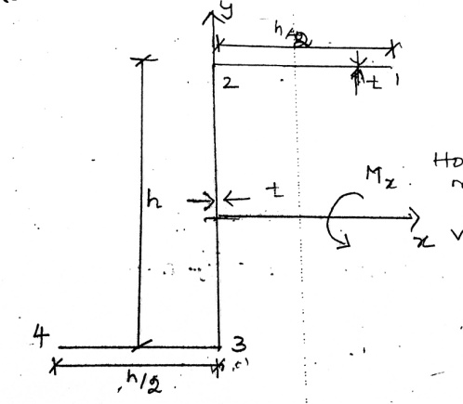 | 13 | CO1 | BTL4
12 | or
12 | b | ii | A bending moment of 3000 Nm is applied to the purlin in a plane at an angle 30° to vertical axis. If the sense of bending moment is such that component Mx and My both produces tension in positive XY quadrant, calculate the maximum direct stress in purlin stating clearly at which point it acts.  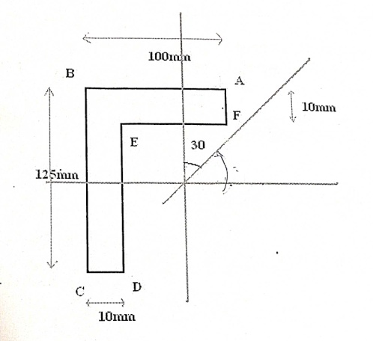 | 13 | CO1 | BTL4
13 | a | i | Find the bending stress at location A and B of I-section and calculate the angle. A 10 kN·m bending moment acts at an angle of 30° as shown in the figure.  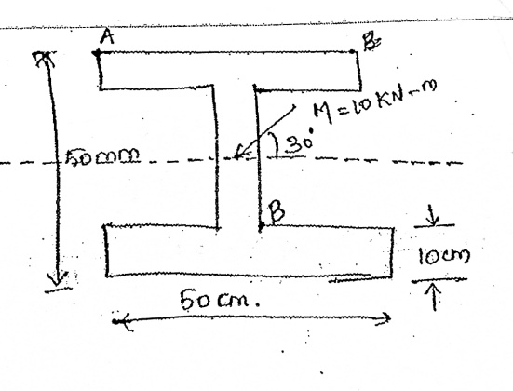 | 14 | CO2 | BTL3
13 | or
13 | b | ii | Derive an expression for determining the shear stress of an open section beam with a neat sketch. | 14 | CO2 | BTL3

Prepared by Verified by

